LEZIONE 28 – 05
MACHINE LEARNING FOR THE ANALYSIS AND CLASSIFICATION OF HUMAN MOVEMENT.
There are many wearable sensors able to measure different parameters:
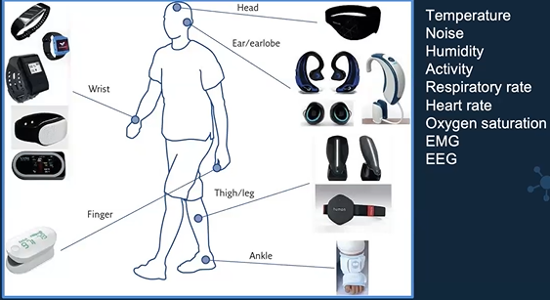
We talk about WEARABLE INERTIAL SENSORS.
- Smartwatch: records human movement
- Smartphone: they embed motion sensors.
- Commercial and prototypes sensors: some of them we buy for other purposes.
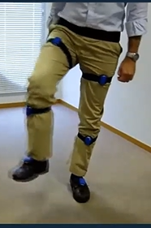

Example.

APPLICATIONS:
- Recognize activities: important when studying movement disorders, like Parkinson’s disease.
- Sport
- Rehabilitation
- Well-being.
- Diagnosis
- Monitoring of neurological disorders.
MONITORING of PARKINSON’S DISEASE.
250.000 subjects in Italy.
It’s the death of dopaminergic neurons, compromises motor control, behaviour, motivation, cognition, sleep, attention and mood.
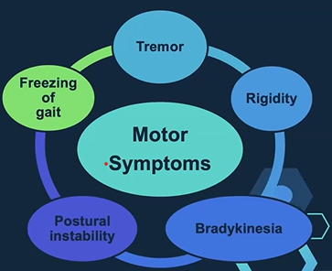
Tremor is the most common.
Rigidity of muscles.
Bradykinesia: slowness of movement.
Postural instability: increases the probability of falls.
Freezing of gait: sudden motor-bock.

Wearable technologies can bring objective evaluations and monitors diseases during daily life.
GAIT ANALYSIS.
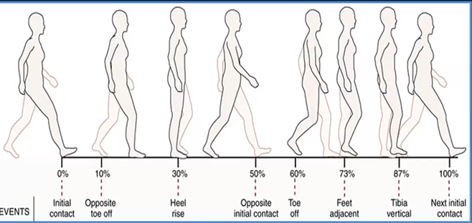
The walking activity is automated in humans. It requires so much coordination. Gait analysis gets information for evaluation of the posture stability.
Gait phases begin with the contact of foot on the ground. Initially only the heel (tallone), after all the foot.

We can get information:
- How much time the foot is in contact with the floor.
- How much time the foot is not in contact with the floor.
People with posture problems prefer to have the foot in contact with floor for as much as possible.

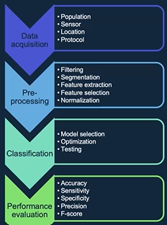

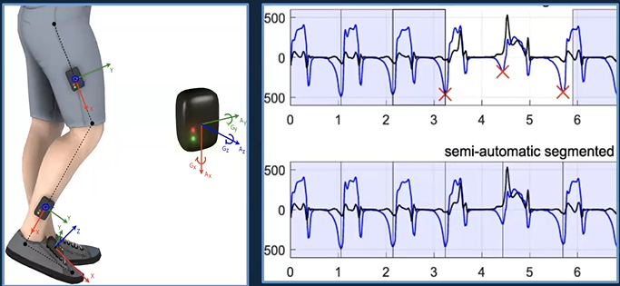
The wearable systems allow to study the movement for long period of time.

The feature extraction can happen by:
- Expert-knowledge
- Direct observation
- Literature
The feature selection can be:
- A-priori. It is FAST, but do not maximize performance.
- Independent of the model
- Independent of the performance.
It is used to maximize performance but is also:
- risk of over-fitting
- time consuming.

DIMENSIONALITY REDUCTION: combining features in other features (optimization). It is:
-independent of the target
-reduce the dimension
- small loss of information.
NORMALIZATION:
It’s about working with values of different scales:
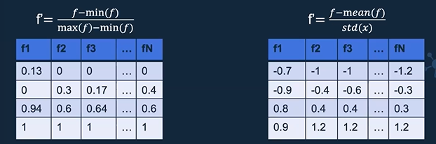
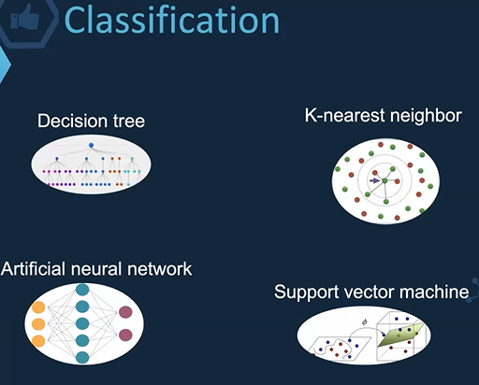
We have different MODELS:

DECISION TREE:
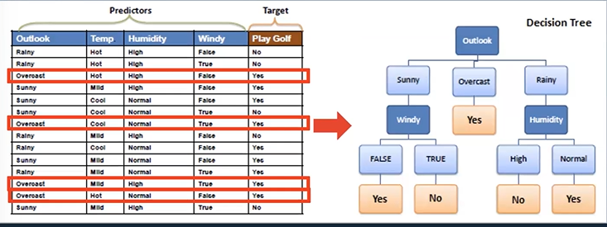
Every time that the outlook is overact, the answer is YES. It’s very related to the target.

K-NEAREST NEIGHBOUR:
-Choose number of neighbours
-Compute the distance from neighbours
-Assign the element to the majority class.
DEEP LEARNING APPROACH.
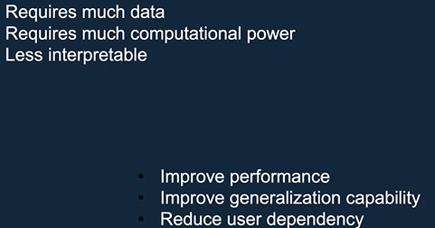

PART 2
A guide to find skeletons in videos:
VISUAL BODY TRACKING.

Analysis of human motion provides immediate insight on alterations of such systems.

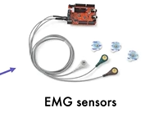
Inertial measurement unit: useful to measure acceleration, or
rotation of human body.
Electrical activity of muscle. Motion capture system
( GOLDEN STANDARD)

Set of video cameras essentially organized inside a laboratory, the person performs motor activities while recorded by cameras. They need to apply some markers on the person.
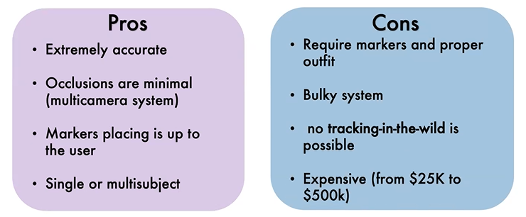

For the next generation VBT system we would something:
- working among in a park, shopping mall, outside a house.
- Low cost
- Markerless.

allow to process videos and images with high performances.

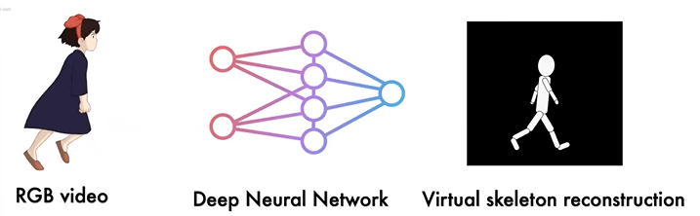
Starting from RGB video, provide directly frames that compose the video, processed by deep neural network. From each frame, it can extract a virtual skeleton reconstruction.

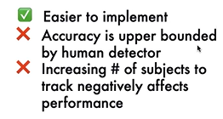
TOP-DOWN APPROACH:
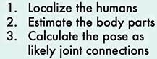
- >

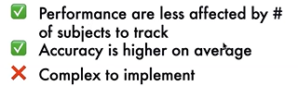
BOTTOM-UP APPROACH:
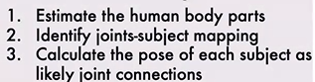
->

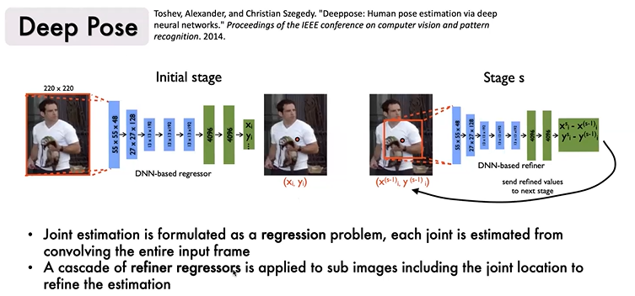

It’s a bottom-up approach.
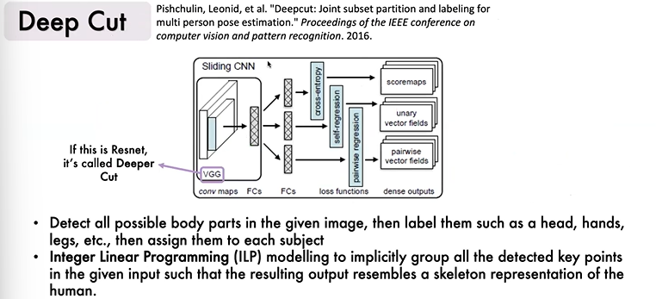

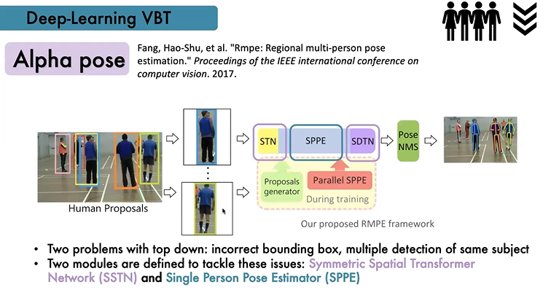

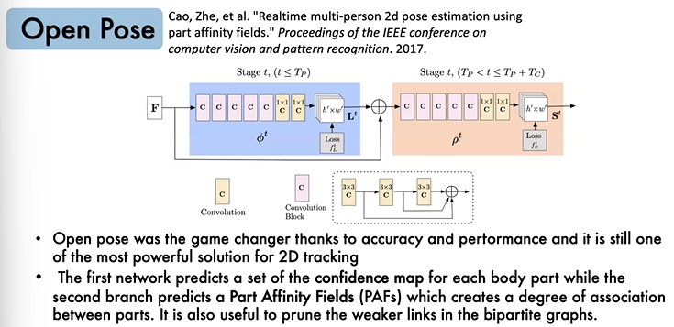
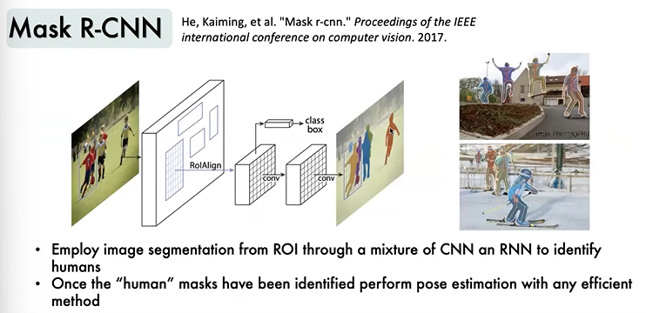
2D provides limited information and fails in identifying complex poses with joint occlusions.
UPLIFTING PROBLEM: we want to identify a way to move to 2D model to 3D model.
The first way is triangulation of 2D coordinates from multiple cameras.
The second is the employ of RGB-Depth cameras (Kinect).
The third is to train the network to estimate directly 3D coordinates.
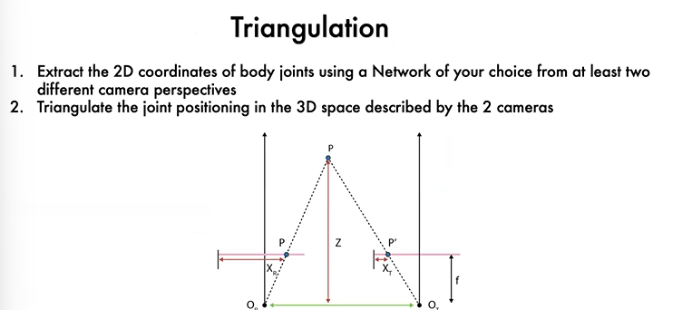
.

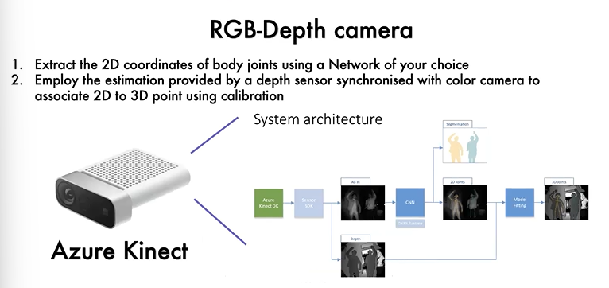
.

3D Pose Estimation Networks.
Employ a double stage network: first stage learns 2D regression, second stage learns how to automatically uplift 2S to 3D from training data projection and reprojection.
Train the whole model directly on monocular videos and images with 3D annotations or synthetic data: BLAZE POSE, neural network architecture.
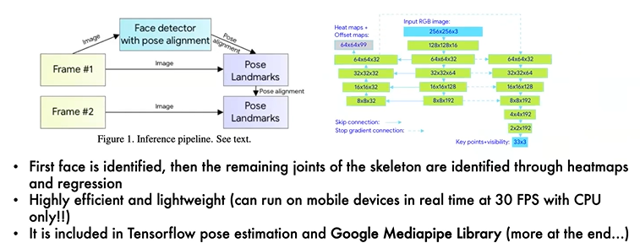

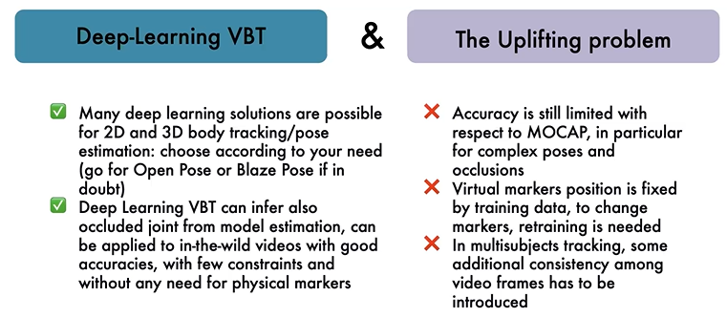


Motion is a reservoir of information about a human being:
- alterations of motor functions are typical in the elderly, people with neurological diseases like Parkinson’s disease or after severe brain injuries (post stroke).

Alterations in how an elderly walks (gait cycle) are strictly related to increase risk of fall and reduced Quality of Life.



